**WEEK5:**

**1.Creating MicroServices for Account and Loan**

**Part 1: Create Folder Structure**

1. Go to your **D: drive**.
2. Create a folder with your **Employee ID** (e.g., D:\123456).
3. Inside that folder, create another folder named microservices.

**Part 2: Create Account Microservice**

1. Open [Spring Initializr](https://start.spring.io/).
2. Fill in the details:
   * **Group**: com.cognizant
   * **Artifact**: account
3. Add Dependencies:
   * **Spring Boot DevTools** (under Developer Tools)
   * **Spring Web**
4. Click **Generate**, and a ZIP file will be downloaded.
5. 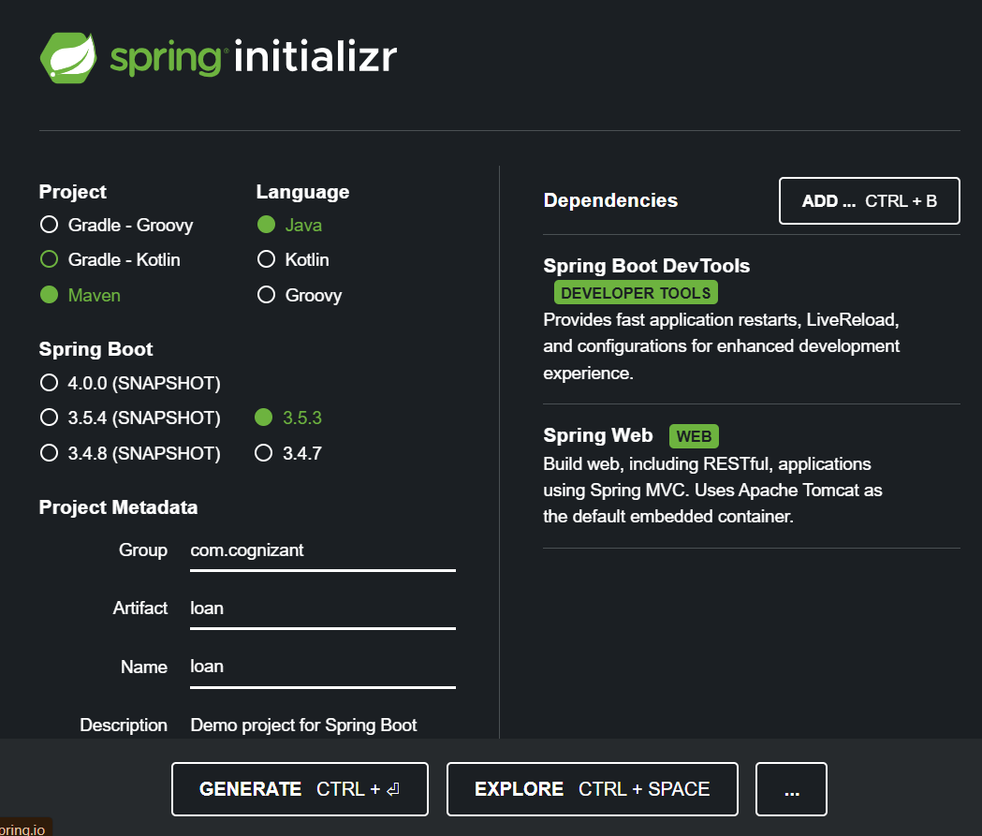
6. Extract it and move the account folder into:

**Part 3: Build with Maven**

1. Open Command Prompt and navigate to:

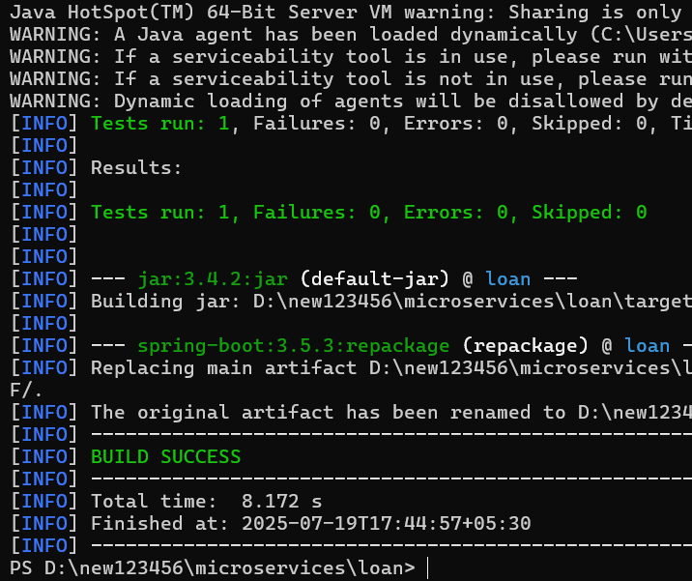

D:\123456\microservices\account

1. Run:

**Part 4: Import into Eclipse**

1. Open **Eclipse** → File → Import → Existing Maven Projects.
2. Browse to:

makefile

Copy code

D:\123456\microservices\account

1. Select the project and import it.

**Part 5: Create Controller for Account**

1. In Eclipse, go to src/main/java/com/cognizant/account/
2. Create a new package: controller
3. Inside it, create a class AccountController.java:

CODE:

package com.cognizant.account.controller;

import org.springframework.web.bind.annotation.GetMapping;

import org.springframework.web.bind.annotation.PathVariable;

import org.springframework.web.bind.annotation.RestController;

import java.util.Map;

@RestController

public class AccountController {

@GetMapping("/accounts/{number}")

public Map<String, Object> getAccountDetails(@PathVariable String number) {

return Map.of(

"number", number,

"type", "savings",

"balance", 234343

);

}

}

1. Run the application from the main class AccountApplication.java (located in the base package).
2. Open browser and go to:

<http://localhost:8080/accounts/00987987973432>

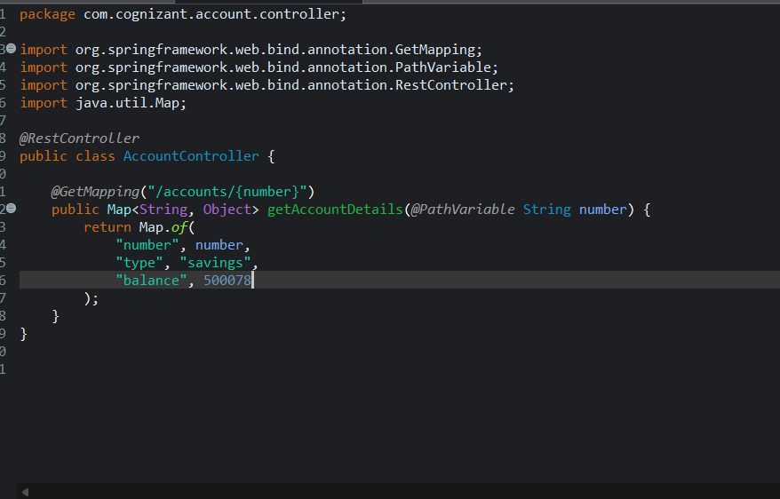

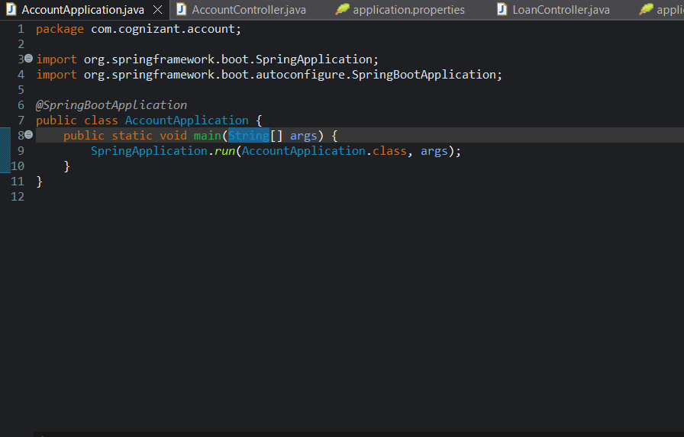

**Part 6: Create Loan Microservice**

Repeat similar steps as for Account:

**1. Spring Initializr:**

* **Group**: com.cognizant
* **Artifact**: loan
* Add:
  + **Spring Boot DevTools**
  + **Spring Web**

**2. Download, Extract, and Move:**

Move to:

makefile

D:\123456\microservices\loan

**3. Build:**

bashcd D:\123456\microservices\loan

mvn clean package

**4. Import into Eclipse:**

Use “Existing Maven Projects” again.

**5. Create Controller:**

In com.cognizant.loan.controller package:

CODE

package com.cognizant.loan.controller;

import org.springframework.web.bind.annotation.GetMapping;

import org.springframework.web.bind.annotation.PathVariable;

import org.springframework.web.bind.annotation.RestController;

import java.util.Map;

@RestController

public class LoanController {

@GetMapping("/loans/{number}")

public Map<String, Object> getLoanDetails(@PathVariable String number) {

return Map.of(

"number", number,

"type", "car",

"loan", 400000,

"emi", 3258,

"tenure", 18

);

}

}

**Part 7: Configure Port for Loan Service**

1. In loan/src/main/resources/application.properties, add:

Properties server.port=8081

**Part 8: Run and Test Both Services**

* Run AccountApplication.java (uses port 8080)
* Then run LoanApplication.java (uses port 8081)
* Test URLs in browser:
  + Account: http://localhost:8080/accounts/00987987973432
  + loan: <http://localhost:9092/loan/00987987973432>

Atlast we have to click console view and after that we have to click display view where you can choose any of the application to run and we run parallely (Account and loan)

